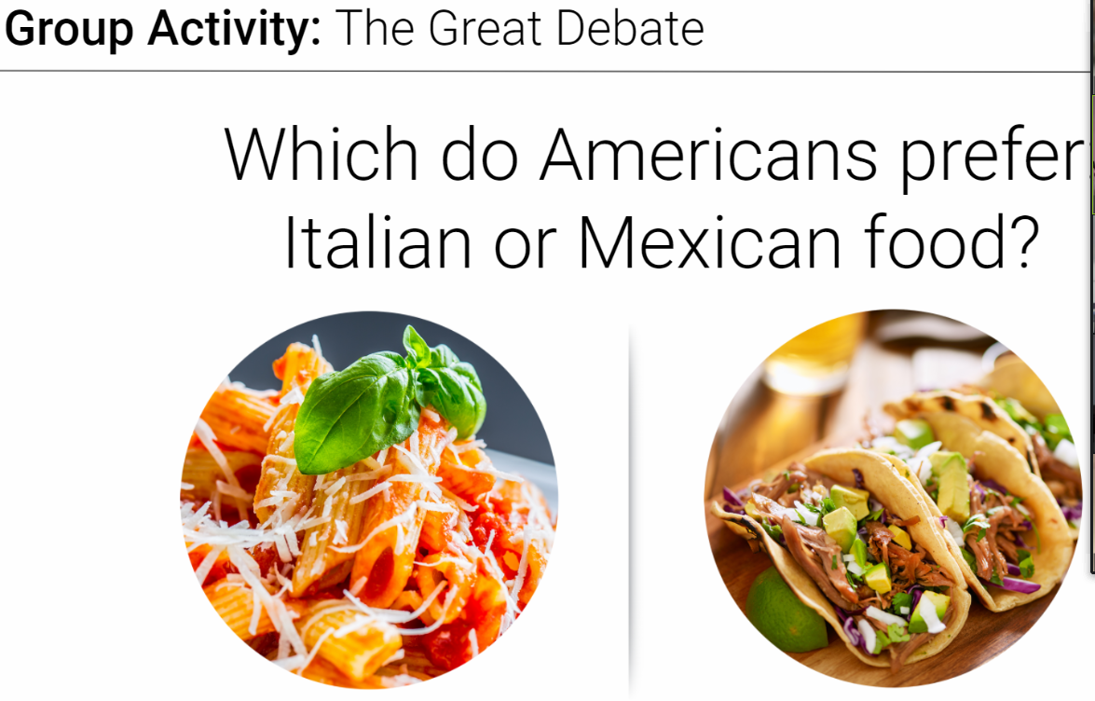

*Assumptions:*

* Total of people living in US.
* How many Italian/Mexican restaurants are in US.
* How are they located in US.
* Urban vs Suburbs?
* Reviews in social media.
* Web Scraping (most liked in social media / most reachable).
* Population Ethnicity / Demography.
* # Restaurants / Populations Density.
* Restaurants opened for each type in a period of time.
* Informal Business.
* Business Closed due to pandemic.
* Profitable Restaurants.
* Migration waves.

*Variables:*

* # Total Number of Restaurants registered in IRS.
* # Likes in social media per post/city.
* # Average cost per type of meal.
* # Trend of open/close restaurants.
* # Population Ethnicity & Density

*Sources:*

* US Census Bureau data.
* IRS data.
* Social Media.

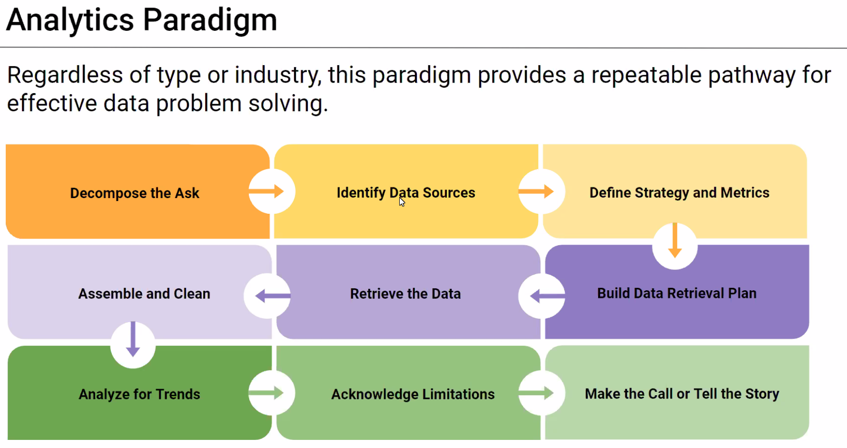

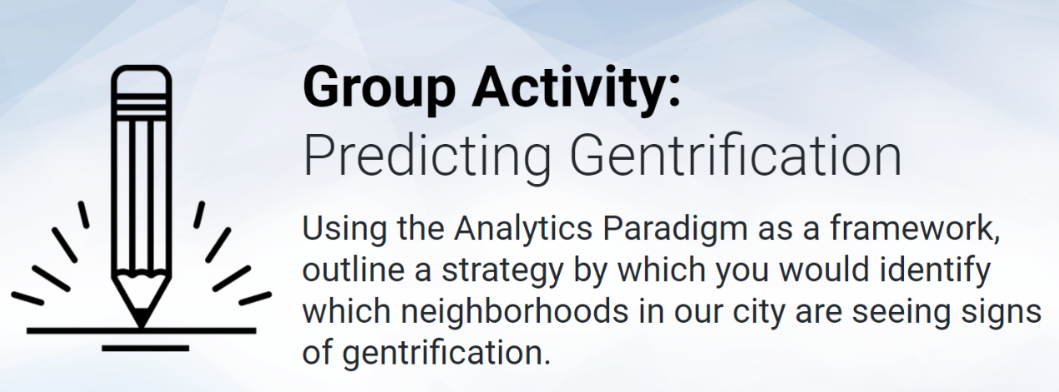

*Assumptions:*

* Define a Place: Querétaro.
* Gentrification > Crime Rates / Unemployment Rates.
* Crisis / Economic Cycles.
* Income / Debt percentage of People.
* Trends of zones becoming gentrificated.
* Public Investment.

*Sources:*

* Average price per M2.
* Government Investment projects / Public Infrastructure project (new highways, schools, hospitals).
* Private Investment projects.
* Construction licenses.
* Economic Growth & Development.
* Economic Census.